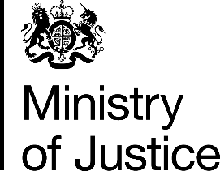 

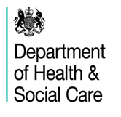

***Independent Advisory Panel on Deaths in Custody***

***Keeping Safe Conference, 25 February 2020***

**AGENDA**

**The Abbey Centre**

**34 Great Smith Street, Westminster, London, SW1P 3BU**

|  |  |  |
| --- | --- | --- |
| **Arrivals and registration** |  | **9.00am** |
| Welcome and Introduction to *Keeping Safe* | Juliet Lyon CBE, Chair of IAP on Deaths in Custody  Erwin James, Editor of Inside Time | 9.30am |
| Welcome and opening address | Nadine Dorries MP, Parliamentary Under Secretary of State for Mental Health, Suicide Prevention and Patient Safety | 9.45am |
| Health and Justice working together to prevent deaths in custody | Kate Davies CBE, NHS England | 10.00am |
| Listening to and supporting people in prison | The Samaritans and former Listeners:  Hazel Alcraft  Magda Tomaszewska,  Berny Gardner and colleagues | 10.10am |
| **Coffee Break** |  | **11.15am** |
| Learning from reports and recommendations to prevent future deaths | HHJ Alexia Durran, Deputy Chief Coroner  Sue McAllister CB, Prison and Probation Ombudsman  Dame Anne Owers, National Chair of Independent Monitoring Boards  Jonathan Tickner, HM Inspectorate of Prisons | 11.30am |
| **Lunch – provided** |  | **12.30pm** |
| Emergency contact line for families | Andy Keen-Downs, Director of PACT and Cleo Metcalf, PACT | 1.30pm |
| Learning from families:  How to gain family support and keep people safe | Deborah Coles, Director of Inquest Donna Mooney and Mark Saunders, family members. | 1.45pm |
| Keynote speech | Robert Buckland QC MP Secretary of State for Justice | 2.40pm |
| Preventing self-harm –  research and practice | Professor Jenny Shaw and  Professor Seena Fazel | 3.10pm |
| ‘*Prison - no place of safety*’ launch | Andrea Albutt, President of Prison Governors Association and Gabrielle Lee OBE, HMPPS | 3.50pm |
| Closing remarks | Phil Copple, Director General of the Prison Service | 4.00pm |
| **End** |  | **4.15pm** |